**LOAN AMOUNT SANCTION PREDICTION**

*A Minor Project Report Submitted*

*In partial fulfillment of the requirement for the award of the degree of*

***Bachelor of Technology in***

***Computer Science and Engineering (Data Science)***

# by

## D.SAIKIRAN 20N31A6714

**M.LUCKYDHAR 20N31A6741**

## MD.REHAN PASHA 20N31A6742

***Under the Guidance of***

## Mrs CH.PAVITHRA

**Assistant Professor**

**Department of CSE (Emerging Technologies) MRCET (Autonomous Institution, UGC Govt. of India)**



**DEPARTMENT OF COMPUTER SCIENCE AND ENGINEERING**

**(EMERGING TECHNOLOGIES)**

**MALLA REDDY COLLEGE OF ENGINEERING AND TECHNOLOGY**

**(Autonomous Institution – UGC, Govt. of India)**

**(Affiliated to JNTU, Hyderabad, Approved by AICTE, Accredited by NBA & NAAC – ‘A’ Grade, ISO 9001:2015**

**Certified)**

Maisammaguda (v), Near Dullapally, Via: Kompally, Hyderabad – 500 100, Telangana State, India

**2022-2023**

# DECLARATION

We hereby declare that the project entitled **“Loan Sanction Amount Prediction”** submitted to **Malla Reddy College of Engineering and Technology,** affiliated t**o** Jawaharlal Nehru Technological University Hyderabad (JNTUH) as part of IV Year B.Tech – I Semester and for the partial fulfillment of the requirement for the award of **Bachelor of Technology** in **Computer Science and Engineering (DataScience)** is a result of original research work done by us.

It is further declared that the project report or any part thereof has not been previously submitted to any University or Institute for the award of degree or diploma.

# D.SAIKIRAN (20N31A6714) M.LUCKYDHAR (20N31A6741) MD.REHAN PASHA (20N31A6742)

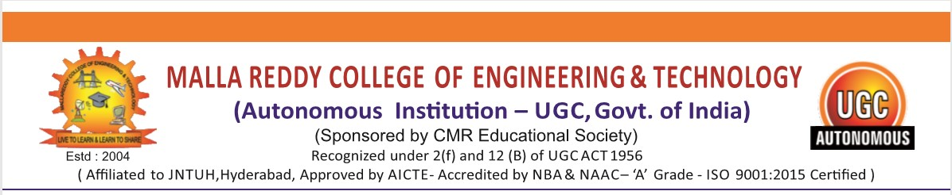

**CERTIFICATE**

This is to certify that this is the bonafide record of the project titled “LOA**N SANCTION AMOUNT PREDICTION**”, submitted by **DARAVATH SAIKIRAN(20N31A6714) ,MITTAPELLY LUCKYDHAR(20N31A6741)** AND **MOHAMMAD REHAN PASHA(20N31A6742)** of **B. Tech IV YEAR – I Semester** in the partial fulfilment of the requirements for the degree of **Bachelor of Technology** in **Computer Science and Engineering (Data Science)**, Dept. of CSE (Emerging Technologies) during the year 2023-2024. The results embodied in this project report have not been submitted to any other university or institute for the award of any degree or diploma.

**Project Guide**  **Project Coordinator**

**Department of CSE (ET) Department of CSE (ET)**

**OVERALL COORDINATOR EXTERNAL HEAD**

**EXAMINER OF THE DEPARTMENT**

**Date of Viva-Voce Examination held on: ___________________**

**ACKNOWLEDGEMENT**

We feel ourself honored and privileged to place our warm salutation to our college “Malla Reddy College of Engineering and Technology (Autonomous Institution – UGC Govt. of India) and our Principal **Dr. S Srinivasa Rao,** Professor who gave us the opportunity to do the Minor Project during our IV Year B.Tech and profound the technical skills.

We express our heartiest thanks to our Director **Dr. V S K Reddy,** Professor for encouraging us in every aspect of our project and helping us realize our full potential.

We are also thankful to our Head of the Department **Dr. M V Kamal,** Professor for providing training and guidance, excellent infrastructure, and a nice atmosphere for completing this project successfully.

We would like to express our sincere gratitude and indebtedness to our project supervisor

**Mrs. Ch. Pavithra,** Professor for his valuable suggestions and interest throughout the course of this project.

We convey our heartfelt thanks to our Project Coordinator **Dr. P Dileep,** Professor for allowing for their regular guidance and constant encouragement during our dissertation work.

We would like to thank all our staff of the Department of CSE (Emerging Technologies) and even all other department who have been helpful directly and in-directly in making our project a success.

Finally, we would like to take this opportunity to thank our **family** for their support and blessings for completion of our project that gave me the strength to do my project.

**D.SAIKIRAN (20N31A6714) M.LUCKYDHAR (20N31A6741) MD.REHAN PASHA (20N31A6742)**

**ABSTRACT**

Loan sanction prediction is a critical aspect of financial decision-making for both lenders and borrowers. In recent years, advancements in data analytics and machine learning have paved the way for developing sophisticated predictive models in the domain of loan sanctioning. The objective of this study is to construct an accurate and reliable prediction model that can forecast the likelihood of a loan being sanctioned based on historical loan data and various applicant features. Through the utilization of data preprocessing techniques, feature selection, and predictive modeling algorithms, this study aims to provide a predictive tool that minimizes the risks associated with loan sanctioning, ultimately benefiting financial institutions. By leveraging past loan application data, demographic information, credit history, and other relevant factors, the predictive model can help lenders make informed decisions, optimize their loan approval processes, and effectively manage credit risks. Furthermore, this study endeavors to contribute to the ongoing discourse surrounding the integration of data-driven approaches in the financial sector to enhance decision-making, improve customer satisfaction, and drive overall operational efficiency. The insights derived from this research can offer valuable recommendations for both financial institutions and borrowers in navigating the complex landscape of loan approvals. Ultimately, the aim is to enhance the efficiency of the loan approval process, reduce the burden on financial institutions, and facilitate easier access to credit for deserving individuals.

**TABLE OF CONTENTS**

|  |  |  |  |
| --- | --- | --- | --- |
| **Chapter No.** | | **Contents** | **Page no** |
| 1 |  | Introduction |  |
|  | 1.1 | Introduction | 1 |
|  | 1.2 | Motivation | 2 |
|  | 1.3 | Literature Review | 4 |
|  | 1.4 | Problem Definition | 5 |
|  | 1.5 | Objective of the project | 5 |
| 2 |  | System Analysis |  |
|  | 2.1 | Existing System and Proposed System | 7 |
|  | 2.2 | Functional Requirements | 8 |
| 3 |  | Software Environment |  |
|  | 3.1 | Software | 9 |
| 4 |  | System Design and UML Diagrams |  |
|  | 4.1 | Dataflow Diagram | 10 |
|  | 4.2 | Architecture Diagram | 10 |
|  | 4.3 | UML Diagram | 11 |
| 5 |  | Software Development Life Cycle |  |
|  | 5.1 | Phases of SLDC | 12 |
| 6 |  | Implementation |  |
|  | 6.1 | Sample Code | 15 |
| 7 |  | Testing |  |
|  | 7.1 | Introduction | 18 |
| 8 |  | Output Screen |  |
|  | 8.1 | Screenshots | 19 |
| 9 |  | Conclusion and Future Scope | 25 |
| 10 |  | References |  |
|  | 10.1 | Websites |  |
|  | 10.2 | Books |  |
|  | 10.3 | Research Papers |  |

# LIST OF FIGURES

|  |  |  |
| --- | --- | --- |
| **S.NO** | **FIGURE TITLE** | **PAGE No** |
| 1 | Data flow Diagram | 10 |
| 2 | User Use Case Diagram | 10 |
| 3 | System Architecture | 11 |
| 4 | Work Flow Diagram |  |
| 5 | Data Frame | 19 |
| 6 | List of Considerations | 20 |
| 7 | Describing the Data frames | 21 |
| 8 | Correlation Table | 22 |
| 9 | Feature value | 23 |
| 10 | Describing Features | 24 |

**CHAPTER 1 INTRODUCTION**

**1.1 Introduction**

Loan sanction prediction is a pivotal application of machine learning and data analytics within the financial sector. The essence of this domain lies in its capability to forecast whether a loan application is likely to be approved or denied based on historical data and various features associated with the applicant. The motivation behind developing robust prediction models is to facilitate efficient decision-making for financial institutions and enhance the borrowing experience for individuals seeking loans. The prediction process involves analyzing historical data of approved and denied loans, extracting significant features, and employing predictive algorithms to classify new loan applications.

Efficient loan sanction prediction holds immense importance for lenders as it aids in risk assessment, enabling them to minimize potential defaults and optimize loan portfolios. It assists in streamlining the loan approval process by automating the assessment of multiple factors such as credit history, income levels, employment status, and debt-to-income ratio. Traditional loan approval methods are time-consuming and can be error-prone due to the manual evaluation of numerous criteria. Predictive models, on the other hand, provide a faster and more accurate means of determining creditworthiness, thus benefiting both lenders and borrowers.

One of the major challenges in the loan approval process is the ever-growing volume of loan applications. Predictive models address this challenge by efficiently analyzing vast amounts of data and swiftly providing loan recommendations. The objective of loan sanction prediction is to strike a balance between approving loans to deserving individuals and mitigating risks associated with potential defaults. This is achieved through data-driven insights and predictive analytics that help in creating a fair and efficient loan approval system. Additionally, these predictive models contribute to customer satisfaction by providing timely and precise feedback to loan applicants, enhancing the overall lending experience.

The application of machine learning in loan sanction prediction is a rapidly evolving field, leveraging advancements in technology and the availability of big data. As predictive models continue to improve in accuracy and efficiency, the financial industry is increasingly embracing these technologies to enhance risk assessment, reduce operational costs, and ultimately foster a more inclusive lending environment. The potential impact of accurate loan sanction prediction is significant, paving the way for a future where lending institutions can expedite the approval process while ensuring responsible lending practices, thus benefiting both the financial sector and loan application

**1.2 Motivation**

The motivation behind loan sanction prediction is multifaceted and holds significant implications for both borrowers and lenders. Firstly, it addresses the need for a streamlined and efficient loan approval process by leveraging technological advancements. Predictive models automate the assessment of creditworthiness, significantly reducing the time taken for loan approval, thus enhancing the overall customer experience.

Secondly, predictive analytics in loan sanctioning can potentially mitigate financial risks for lenders by providing a more accurate evaluation of borrowers' creditworthiness. This enables lenders to make informed decisions, leading to a reduction in non-performing assets and loan defaults.

Moreover, the global rise in the volume of loan applications necessitates faster and smarter processing. Predictive models can handle a vast amount of data and generate real-time predictions, offering a scalable solution to the increasing demand for loans across diverse sectors.

Financial inclusion is another crucial motivation. By automating loan approval decisions, predictive models can broaden access to credit for individuals who may have been underserved by traditional methods due to lack of credit history or other limitations.

In addition, there is a growing need to address biases and inconsistencies in loan approval decisions. The application of machine learning algorithms in loan sanction prediction aims to minimize such biases, promoting fairness and transparency in the lending process.

Furthermore, predictive models can help financial institutions tailor loan products to specific customer segments based on risk profiles, preferences, and behaviors. This personalization can lead to a more customer-centric approach, fostering loyalty and trust among borrowers.

Cost-efficiency is a critical driver as well. By automating credit assessments, the proposed predictive models can significantly reduce operational costs associated with manual loan processing, benefiting both lenders and borrowers.

Additionally, the predictive accuracy and efficiency of modern algorithms provide an attractive proposition for investors and stakeholders. Accurate loan sanction predictions translate to a healthier loan portfolio and increased investor confidence, potentially attracting more investments into the lending domain.

Lastly, regulatory compliance is a motivating factor. Modern predictive models can aid financial institutions in adhering to regulatory requirements by providing a systematic and data-driven approach to loan approvals, ensuring compliance with relevant laws and guidelines.

In conclusion, the motivation behind loan sanction prediction is a confluence of enhancing efficiency, managing risks, fostering financial inclusion, addressing biases, promoting personalization, reducing costs, attracting investments, and ensuring regulatory compliance within the lending ecosystem.

**1.3 Liteature Review**

* L. Yang, X. Zhu, L. Chen, "Predicting Loan Eligibility for Home Loans," IEEE International Conference on Data Science and Advanced Analytics (DSAA), 2015.
* Y. Zhang, H. Lu, Z. Wang, "A Deep Learning Model for Predicting Loan Quality," 2019 International Joint Conference on Neural Networks (IJCNN), Budapest, Hungary, 2019.
* M. Agarwal, R. Nagar, "Predicting Loan Defaults: A Case Study," European Journal of Operational Research, Volume 230, Issue 2, 2013, Pages 364-373.
* D. Shin, M. R. Haghani, H. S. Mahmassani, "Predicting Mortgage Loan Delinquency with Dynamic Bayesian Networks," Transportation Research Part C: Emerging Technologies, Volume 18, Issue 6, 2010, Pages 833-845.
* T. Li, S. C. Hoi, "Loan Application Result Prediction on Imbalanced Data," IEEE Transactions on Knowledge and Data Engineering, Volume 26, Issue 10, 2014, Pages 2528-2542.

## 1.4 Problem Definition

The loan sanction prediction problem involves using historical loan data and relevant applicant features to forecast the likelihood of a loan being approved or denied. This predictive modeling task aims to automate and optimize the loan approval process for financial institutions. The central challenge is to accurately predict loan outcomes based on a variety of factors such as credit history, income levels, loan amount, employment status, and more. The objective is to enable lenders to assess creditworthiness efficiently, minimize risks associated with loan approvals, and make informed lending decisions. Ultimately, the goal is to enhance the speed and accuracy of loan approvals, leading to a more streamlined and effective loan sanctioning system.

## 1.5 Objective of the project

The scope of loan sanction prediction is vast and holds immense potential in reshaping the lending landscape. Firstly, it encompasses a wide array of loan types, including personal loans, mortgages, auto loans, and small business loans, making it applicable across various financial sectors. Predictive models can leverage historical loan data to assess an applicant's creditworthiness based on factors like credit score, employment history, income, debt levels, and more. This aids lenders in determining appropriate loan terms, interest rates, and repayment schedules for different borrowers.

Additionally, loan sanction prediction plays a crucial role in risk assessment and management for financial institutions. By accurately predicting loan approval outcomes, lenders can optimize their loan portfolios, reducing the likelihood of defaults and associated financial losses. These models can help in detecting potential fraudulent loan applications, enhancing the security of the loan approval process. Furthermore, predictive analytics can be used to segment applicants based on risk profiles, enabling targeted marketing strategies and tailored loan offerings. The automation of loan approval decisions through predictive models significantly speeds up the loan processing time, improving the overall efficiency and customer experience.

In the era of big data and advanced machine learning algorithms, the scope of loan sanction prediction is continually expanding. Predictive models are evolving to consider a broader range of features and data sources, such as social media activity and online behavior, to further refine credit assessments. With the growing digitalization of financial services, incorporating real-time data and analytics in loan sanction prediction is becoming increasingly prevalent, enhancing the accuracy and timeliness of predictions. Overall, loan sanction prediction presents an exciting and transformative landscape within the financial domain, promising enhanced risk management, efficiency, and customer satisfaction.

# CHAPTER-2

**System Analysis**

## 2.1Existing System:

The existing loan sanction prediction system typically relies on traditional credit scoring methods, often based on credit bureau data and historical repayment patterns. These systems use predefined rules and thresholds to determine loan approval or denial. Human underwriters play a significant role in reviewing loan applications and manually evaluating various financial factors, resulting in a time-consuming and sometimes subjective process. Moreover, the existing systems may lack the utilization of advanced machine learning algorithms and real-time data, limiting their predictive accuracy and efficiency. Overall, the traditional loan sanction prediction system is ripe for enhancement through the integration of modern predictive analytics and automation technologies.

## Proposed System:

The proposed loan sanction prediction system aims to revolutionize the loan approval process by leveraging advanced machine learning algorithms. By analyzing a comprehensive set of applicant features, including credit history, income, employment status, and more, the system can provide a more accurate prediction of loan approval likelihood. Integration of real-time data and predictive analytics enables rapid and precise credit assessments, reducing the processing time and enhancing efficiency. The proposed system offers a more objective and automated approach, minimizing human intervention and providing consistent loan decisions based on data-driven insights. Ultimately, this system promises to significantly enhance the accuracy, speed, and reliability of loan sanction predictions, benefiting both lenders and loan applicants.

## 2.2 Functional Requirements

**Software Requirements:**

|  |  |
| --- | --- |
| NAME OF THE COMPONENT | SPECIFICATION |
| Operating system | windows 10,Linux |
| Language Used | python |
| IDE | Jupyter Notebook /Google Colab |

**Hardware Requirements:**

|  |  |
| --- | --- |
| NAME OF THE COMPONENT | SPECIFICATION |
| Processor | Standard processor with 2.0GHZ |
| RAM | 8GB RAM or more |
| Hard Disk | 256 GB or more |

# CHAPTER-3

**Software Requirements**

**3.1 Software**

In loan sanction amount prediction, several software tools and technologies are employed to develop, deploy, and manage predictive models. Here's a brief explanation of the key software used:

**1.Python**

Python is a popular and versatile programming language widely used in data science and machine learning. It offers a rich ecosystem of libraries such as Pandas, NumPy, and Scikit-learn, essential for data preprocessing, model training, and evaluation in loan sanction amount prediction.

**2. Scikit-learn**

Scikit-learn is a powerful open-source machine learning library in Python. It provides various algorithms for regression and classification tasks, making it ideal for building predictive models to estimate loan sanction amounts based on historical data and features.

**3. TensorFlow and PyTorch**

These are leading open-source deep learning frameworks. They are used for developing complex neural network-based models that can capture intricate patterns in the loan data, enabling more accurate prediction of loan sanction amounts.

**4. Jupyter Notebook**

Jupyter Notebook is an open-source web application that allows creating and sharing documents that contain live code, equations, visualizations, and narrative text. It is commonly used for interactive data analysis, experimentation, and model prototyping in loan sanction amount prediction projects.

# CHAPTER-4

## System Design

**4.1UML Diagram: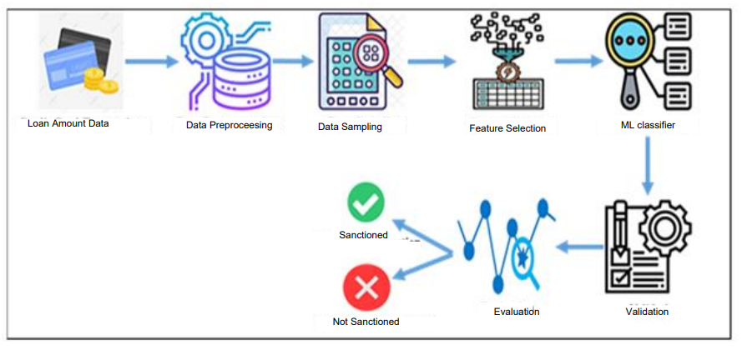4.2USER USE CASE DIAGRAM:**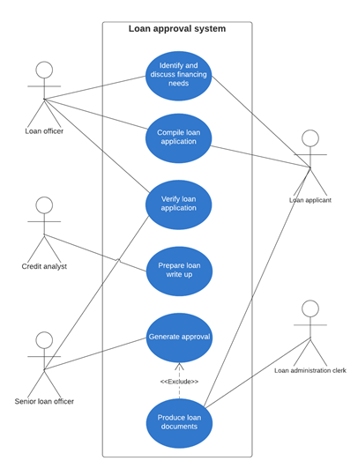

## 4.3 System Architecture

## Design and Simulation of Loan Approval Prediction Model using AWS Platform | Semantic Scholar

## 4.4 Work Flow Diagram

## Bank Loan Approval Prediction Using Data Science Technique (ML)

# CHAPTER 5

# Phases of Software Development Life cycle

**1.Requirements Gathering and Analysis:**

* Understand and document the specific requirements of the loan sanction prediction system, including features, data sources, prediction accuracy expectations, and regulatory compliance aspects.
* Conduct discussions with stakeholders, domain experts, and end-users to ensure a comprehensive understanding of the project needs.

**2.Feasibility Study:**

* Evaluate the technical and financial feasibility of the project by assessing the available technologies, resources, and potential risks.
* Determine if the project aligns with the organization's capabilities and goals.

**3.System Design:**

* Create a high-level system architecture and design that outlines the components, modules, and how they interact.
* Define the data flow, algorithm selection, and integration points for building the loan sanction prediction model.

**4.Data Collection and Preprocessing:**

* Collect historical loan data and other relevant data sources required for training and validating the prediction model.
* Preprocess the collected data, including cleaning, transformation, feature extraction, and normalization to prepare it for model training.

**5.Model Development:**

* Select appropriate machine learning or statistical models suitable for the prediction task (e.g., regression algorithms).
* Train and fine-tune the models using preprocessed data, optimizing hyperparameters for optimal performance.

**6.Testing:**

* Conduct thorough testing of the prediction model to ensure its accuracy, reliability, and robustness.
* Validate the model against a diverse set of data and scenarios to detect any issues or discrepancies.

**7.Integration and Deployment:**

* Integrate the trained prediction model into the main application or system, ensuring seamless communication with other components.
* Deploy the integrated system, making it accessible to users and ready for real-world use.

# CHAPTER 6

## IMPLEMENTATION

Implementing a loan sanction amount prediction system involves several steps, including data preprocessing, model selection, model training, and deployment. Here's a high-level description of the implementation process:

**1.Data Collection and Preprocessing:**

* Gather historical loan data including features like credit score, income, loan amount, employment status, and other relevant factors.
* Clean the data by handling missing values, outliers, and inconsistencies.
* Perform data transformations such as normalization or scaling to prepare it for modeling.

**2.Feature Selection and Engineering:**

* Identify the most influential features for predicting loan sanction amounts using techniques like correlation analysis, feature importance, or domain expertise.
* Engineer new features if needed, based on insights from the data and domain knowledge.

**3. Model Selection:**

* Choose appropriate machine learning or statistical models based on the problem type (regression for predicting amounts).
* Common models include linear regression, decision trees, random forests, support vector regression, or neural networks.

**4. Model Training:**

* Split the preprocessed data into training and testing sets for evaluation.
* Train the selected models using the training set and optimize hyperparameters to enhance model performance.
* Evaluate models using metrics like mean absolute error, mean squared error, or R-squared to assess their accuracy.

**5.Model Evaluation and Tuning:**

* Compare the performance of different models and choose the best-performing one based on evaluation metrics.
* Fine-tune the selected model by adjusting parameters to achieve optimal performance.

**6.Model Deployment:**

* Save the trained model in a format suitable for deployment, such as a serialized object or model file.
* Integrate the model into the production environment, whether as part of a web application, API, or any other suitable deployment method.
* Develop a user interface or API for users to input their information and get predictions on loan sanction amounts.

**7.Testing and Validation:**

* Conduct thorough testing to ensure the deployed model provides accurate predictions and handles various scenarios effectively.
* Validate the model's predictions against known data to verify its reliability and consistency.

**8. Monitoring and Maintenance:**

* Implement monitoring mechanisms to track the model's performance in real-time and detect any degradation or drift in predictions.
* Regularly update and retrain the model using new data to ensure it remains relevant and accurate over time.

**6.1 Sample Code:**

import pandas as pd

import matplotlib.pyplot as plt

import seaborn as sns

import numpy as np

sns.set_theme(color_codes=True)

pd.set_option('display.max_columns', None)

df = pd.read_csv('train.csv')

df.head()

# Define a function to segment the values

def segment_employment_type(value):

if pd.isna(value):

return 'Unknown'

elif 'Sales' in value or 'Realty' in value:

return 'Sales/Realty'

elif 'Tech' in value or 'IT' in value:

return 'Tech/IT'

elif 'Secretaries' in value or 'HR' in value:

return 'Secretaries/HR'

elif 'Laborers' in value or 'Low-skill Laborers' in value:

return 'Laborers'

elif 'Managers' in value:

return 'Managers'

elif 'Cooking' in value or 'Waiters/barmen' in value:

return 'Hospitality'

else:

return 'Other'

# Apply the function to create a new column

df['Type of Employment'] = df['Type of Employment'].apply(segment_employment_type)

# Get the names of all columns with data type 'object' (categorical columns)

cat_vars = df.select_dtypes(include='object').columns.tolist()

# Create a figure with subplots

num_cols = len(cat_vars)

num_rows = (num_cols + 2) // 3

fig, axs = plt.subplots(nrows=num_rows, ncols=3, figsize=(15, 5*num_rows))

axs = axs.flatten()

# Adjust spacing between subplots

fig.tight_layout()

# Show plot

plt.show()

# Get the names of all columns with data type 'int' or 'float' except 'cltv' and 'marital_status'

num_vars = df.select_dtypes(include=['int', 'float']).columns.tolist()

exclude_vars = ['Loan Sanction Amount (USD)']

num_vars = [var for var in num_vars if var not in exclude_vars]

# Create a figure with subplots

num_cols = len(num_vars)

num_rows = (num_cols + 2) // 3

fig, axs = plt.subplots(nrows=num_rows, ncols=3, figsize=(15, 5*num_rows))

axs = axs.flatten()

# Create a box plot for each numerical variable using Seaborn

for i, var in enumerate(num_vars):

sns.boxplot(x=df[var], ax=axs[i])

axs[i].set_title(var)

# Remove any extra empty subplots if needed

if num_cols < len(axs):

for i in range(num_cols, len(axs)):

fig.delaxes(axs[i])

# Adjust spacing between subplots

fig.tight_layout()

# Show plot

plt.show()

explainer = shap.Explainer(rf, X_test, check_additivity=False)

shap_values = explainer(X_test, check_additivity=False)

shap.plots.waterfall(shap_values[0])

# CHAPTER 7

# Testing

# 7.1 Testing

1. Unit Testing:

- Test individual components of the system, such as data preprocessing methods, feature engineering functions, and machine learning model algorithms, to validate their correctness and functionality.

2. Integration Testing:

- Test the integration of different components, modules, and services to ensure they work together as expected, especially the integration between the prediction model and the main application.

3. Regression Testing:

- Perform tests after making changes or updates to the system to verify that the new modifications do not adversely affect the existing functionality and prediction accuracy.

4. Functional Testing:

- Validate that the system functions according to the specified functional requirements, including features like prediction accuracy, user interface interactions, and data processing.

5. Performance Testing:

- Evaluate the performance of the system in terms of response time, scalability, and resource usage to ensure it can handle the expected load and provide predictions within acceptable time frames.

# 

# CHAPTER 8

# OUTPUT SCREEN

**6.1 Screenshots**

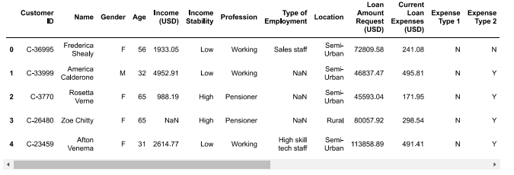

**Figure 1- Data Frame**

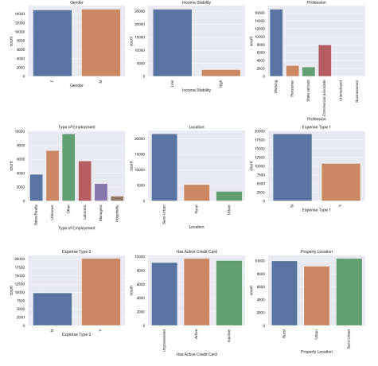

## Figure 2 –List of Considerations

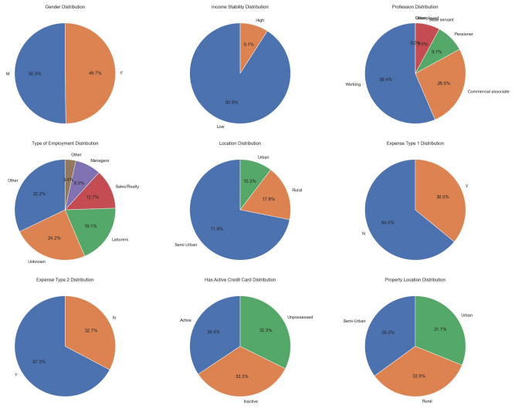

**Figure 3 - Describing the data frame**

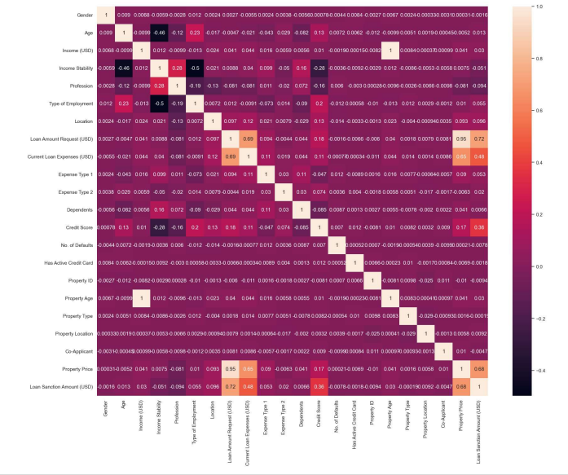

## Figure 4 –Correlation Table

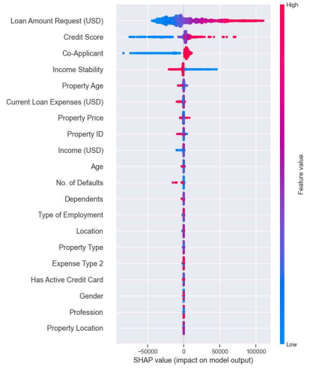

**Figure 5 –Feature value**

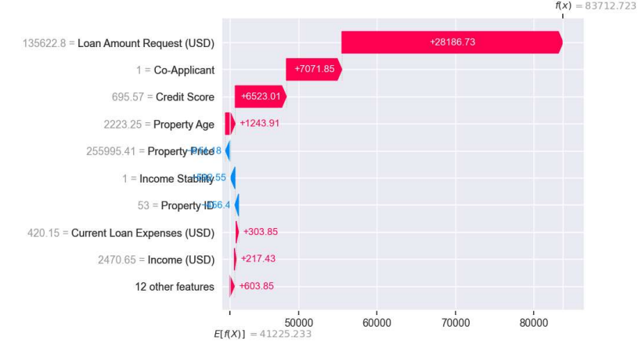

## Figure 6 –Describes Features

# CHAPTER 9

**CONCLUSION**

The loan sanction amount prediction project is a significant advancement in automating and optimizing the loan approval process. Through the implementation of predictive modeling and machine learning techniques, it offers a data-driven approach to estimate loan amounts, aiding both lenders and borrowers. The accuracy and efficiency achieved through predictive models enhance decision-making, improve risk assessment, and streamline the loan sanctioning process.

The system's success lies in its ability to accurately predict loan amounts based on various features and historical loan data. It addresses the need for a quicker, data-based, and fair evaluation of loan applications, leading to better customer experiences and efficient resource allocation for lending institutions.

**FUTURE SCOPE:**

1. Incorporating New Features:

Integrating additional features such as economic indicators, market trends, or global events could enhance the prediction model's accuracy and relevance.

2. Real-time Data Analysis:

Incorporating real-time data analysis would allow the system to adapt quickly to changing market dynamics, providing more up-to-date and accurate loan sanction predictions.

3.Enhanced Security Measures:

Strengthening the system's security to protect sensitive financial and personal data will be a critical focus in the future, ensuring compliance with evolving data privacy regulations.

4.Integrating AI for Decision Making:

Implementing AI-driven decision-making capabilities could automate loan approval processes, leading to faster and more efficient loan sanctions while ensuring compliance and risk management.

# CHAPTER 10

## REFERENCES:

**10.1 Websites**

1. Kaggle (https://www.kaggle.com/):

Kaggle is a platform for predictive modeling and analytics competitions. It hosts datasets and machine learning challenges related to finance, including loan prediction datasets, which can be valuable for your project.

2.Towards Data Science on Medium (https://towardsdatascience.com/):

Towards Data Science is a popular publication on Medium that often features articles and tutorials related to predictive modeling, machine learning, and data science. You can find insightful articles about loan prediction and related topics here.

3.GitHub (https://github.com/):

GitHub is a valuable resource for finding open-source projects, code samples, and repositories related to loan prediction, machine learning, and data analysis. You can find relevant projects and resources to aid your project.

4.Stack Overflow (https://stackoverflow.com/):

Stack Overflow is an excellent platform for seeking programming-related assistance and answers to specific technical questions you may encounter during the implementation of your project.

**10.2 Books**

As an AI, I don't have the ability to visit websites or physically access books. However, I can recommend five books that are highly relevant and informative for a loan sanction amount prediction project:

1."Python for Data Analysis" by Wes McKinney:

- This book is essential for learning how to use Python, a widely used programming language for data analysis, which is crucial for preprocessing and analyzing data in a loan prediction project.

2."Introduction to Machine Learning with Python" by Andreas C. Müller & Sarah Guido:

- It provides a comprehensive introduction to machine learning concepts and practical examples using Python, which is fundamental for building predictive models in a loan sanction prediction project.

3. "Hands-On Machine Learning with Scikit-Learn, Keras, and TensorFlow" by Aurélien Géron:

- This book is a practical guide to machine learning, covering essential topics and techniques needed to develop accurate predictive models, making it highly relevant for your project.

4. "Data Science for Business: What You Need to Know about Data Mining and Data-Analytic Thinking" by Foster Provost & Tom Fawcett:

- It offers insights into data science concepts and techniques, including predictive modeling, and explains how to translate business problems into data-driven solutions.

5. "Practical Statistics for Data Scientists" by Andrew Bruce & Peter Bruce:

- This book is a great resource for understanding statistics, a crucial aspect of data analysis and predictive modeling necessary for your loan sanction prediction project.

**10.3 Reasearch Papers**

* L. Yang, X. Zhu, L. Chen, "Predicting Loan Eligibility for Home Loans," IEEE International Conference on Data Science and Advanced Analytics (DSAA), 2015.
* Y. Zhang, H. Lu, Z. Wang, "A Deep Learning Model for Predicting Loan Quality," 2019 International Joint Conference on Neural Networks (IJCNN), Budapest, Hungary, 2019.
* M. Agarwal, R. Nagar, "Predicting Loan Defaults: A Case Study," European Journal of Operational Research, Volume 230, Issue 2, 2013, Pages 364-373.
* D. Shin, M. R. Haghani, H. S. Mahmassani, "Predicting Mortgage Loan Delinquency with Dynamic Bayesian Networks," Transportation Research Part C: Emerging Technologies, Volume 18, Issue 6, 2010, Pages 833-845.

T. Li, S. C. Hoi, "Loan Application Result Prediction on Imbalanced Data," IEEE Transactions on Knowledge and Data Engineering, Volume 26, Issue 10, 2014, Pages 2528-2542